**Instructions for Automated LCS Matlab Program (*name pending*)**

**About LCS Matlab Program (*name pending*)**

This MATLAB program is based off of an earlier work which calculated LCS found here: http://dabirilab.com/software/. The program downloads eight days worth of data from http://coastwatch.pfeg.noaa.gov/erddap/griddap/ncepRtofsG2DFore3hrlyProg.html on each day. The program is then fed into an LCS calculation program and pictures of the plot are saved.

**Requirement for operation system and MATLAB**

This program was created using MATLAB 2014. (*enter the toolbox stuff we need here*). The program is written for Linux but can be run on Windows, changes will need to be made in the code. An automatic scheduling program will be needed. Testing was done using Crontab for Linux.

**How to Use**

Step 1. Initialization

1.1 Run MATLAB

1.2 Open testui.m and run it

1.3 The Graphical user Interface (GUI) shows like Fig 1.1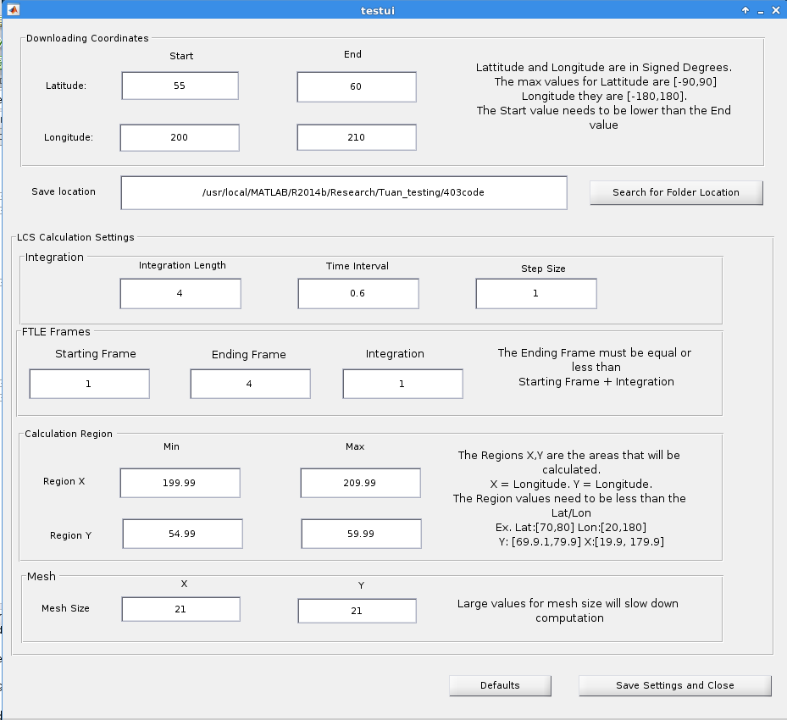

Figure 1.1

1.4 Input the parameters

**Downloading Coordinates -** Lets you change the values of which areas of Earth you want to pull data from. The units for latitude and longitude are signed degrees, this means that values go from

-180 to 180 for longitude, if the number is negative it means left of the Greenwich line, if it is positive then it signifies right of the line. Latitude goes from -90 to 90, negative denotes south of the equator and positive means north of the equator. The start and end values represent the leftmost and the rightmost coordinates for longitude and the lowest to highest coordinates for latitude. The program will not work correctly if the value for start is higher than the value for end.

**Save Location** - Specifies where the data that is downloaded and formatted will be stored. You can type in the file location or you can search for it using the search for folder button, it will bring up a window to make it easier to search.

If you are using a Windows Machine

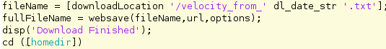

Change '/velocity_from_' to '\velocity_from_' inside the downloadDataFcn.m

**LCS Calculation** - Deals with variables that are used when calculating LCS from the downloaded data.

**Integration** - This section needs further development. Integration Length is the time duration in frames for integration. Time Interval is measured in seconds, right now it only works if the value is less than one. The step size should normally be set to one.

**FTLE Frames** - The variables here deal with how many days worth of data are being downloaded, usually they will not be changed. Currently the program downloads eight days worth of data that is then split into 64 frames. Normally the starting frame will be set to 1. The ending frame and the integration values can be set to whatever you like, but the ending frame plus integration must not exceed 64.

**Calculate Region Size** - The area inside of the data you collected that you wish to examine. The x value corresponds to longitude and the y value corresponds to the latitude. Usually you will want to calculate on the entire region of the data you put in so it is normal to go .1 less the values you put in the download coordinates section at the top of the window.

**Mesh** - Akin to the resolution of the plot after running the calculations on the data. As you increase the values of the mesh size you will get a more refined image but computation time will increase. Low values around the twenties are not very precise so values over a hundred are recommended.

At the bottom are two buttons, default will set the parameters to the values used during testing. You will still need to set a folder to download to. The save settings and close button will save the parameters in the textboxes and close the GUI.

Step 2. Run the program

2.1 (*put setup for cron here*)

2.2 Images of the plot will be saved inside of the folder you chose "x/formatted_data/date/MatFiles/"

**Notes**

The program still needs development, the LCS calculation can use threading to speed up the calculation process, this will be important if mesh size values are large. The x y values for coordinates need to be converted from degrees to KM to properly be used in the LCS calculation with the time interval which is in seconds. The formatted data and Matfiles created while processing are not needed, only the image of the graphs are needed. As these are essentially tempfiles it would be a good idea to delete them after the program runs. And finally the NOAA website that the files are downloaded from sometimes hasn't update their database by the time the program runs. A check method to try and redownload if it fails should be implemented.